Testplan Badge

BY_AMP P1_7
BY_AMP_N P2_5

TX_AMP P5_6
RX_LNA P6_7

TX_RX P2_10
TX_RX_N P2_11

BY_MIX P2_12

LOW_HIGH_FILT P5_2
LOW_HIGH_FILT_N P5_3

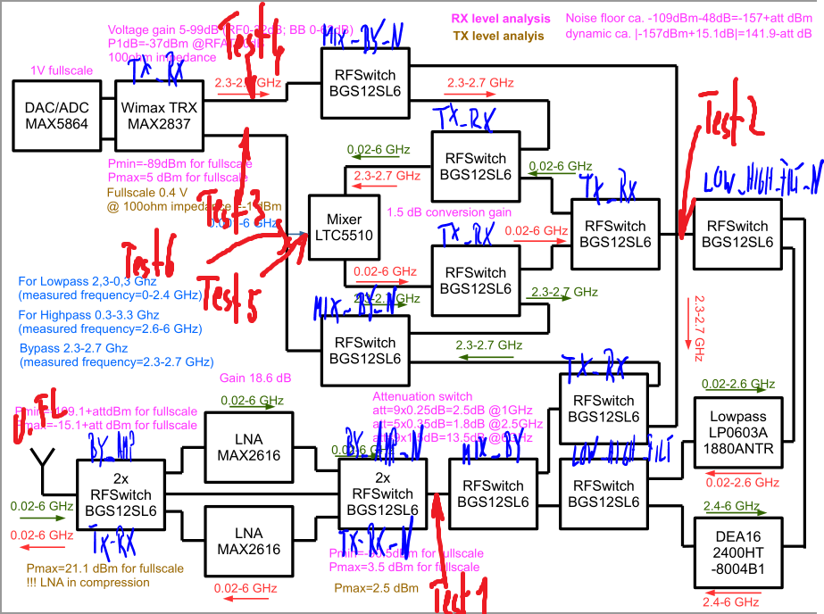
1. LNA-Path

1.1 Overview
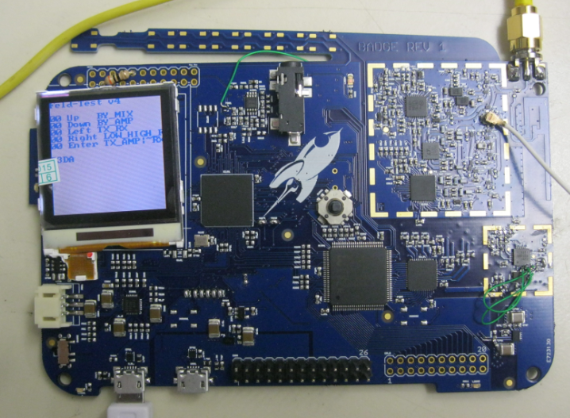
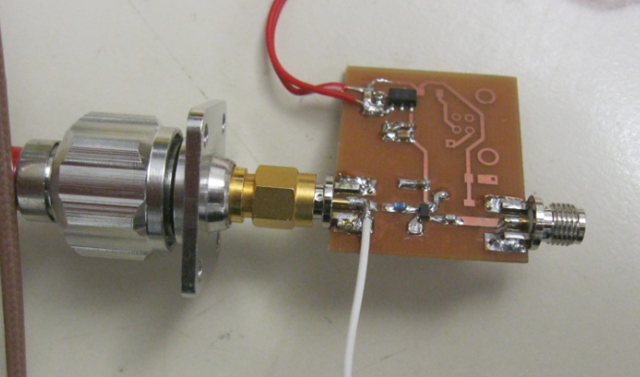
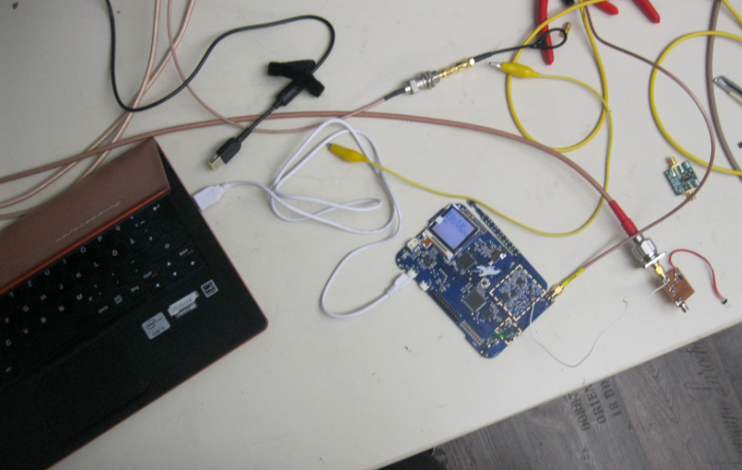
1.2 Emission of the RF-Path
A RF-Sniffer was built to see if there is any emission during to oscillating of the amplifiers. At the beginning both amplifiers (LNA and Transmitting AMP) was set to run. Because of the feedback a oscillation at about 6.5 GHz started. But when only one amplifier is on everything is all right. The next two pictures show the measurement of the complete frequency band.
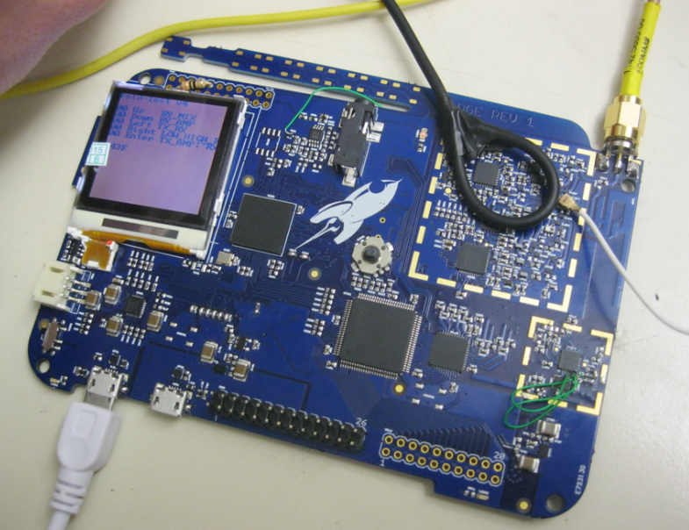
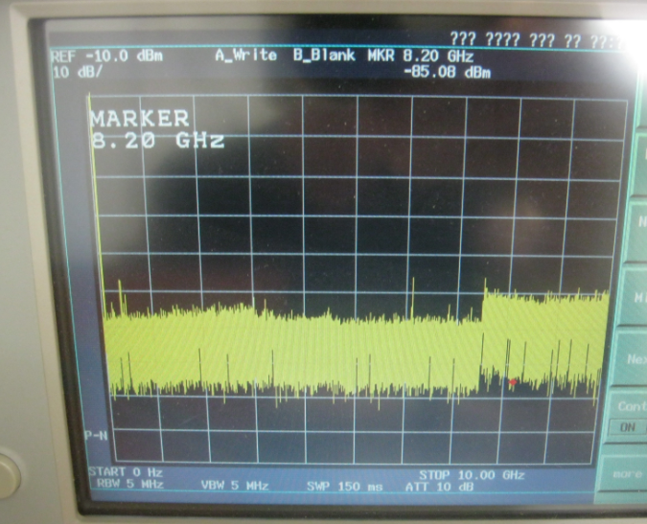
1.3 Transmision and amplification
The next picture shows the transmission in the bypass mode. The calibration was done with the N-Calkit. The cables to the UFL-Connector and the SMA is not in the calibration. Therefore this attenuation is also in the measurement. The green line is the evaluation board of the amplifier which will be in all pictures the same. The yellow line is the bypass mode.
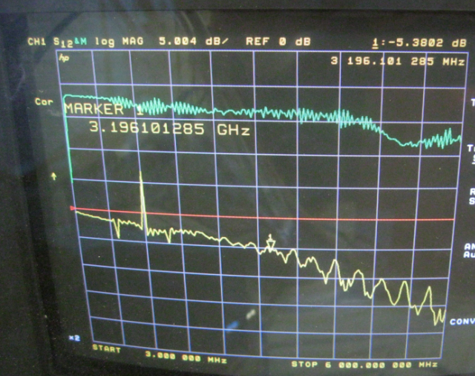
The next picture gives the LNA-curve curve.
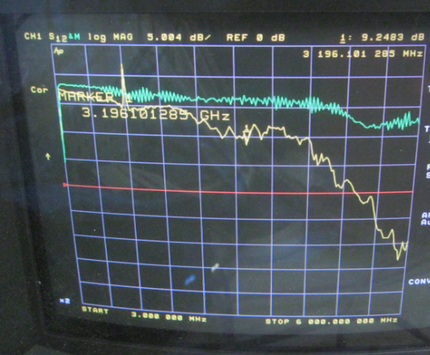
The next picture shows the TX-amplifier

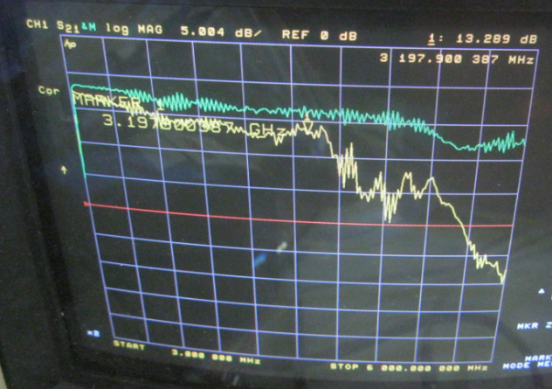
2. Input and Output of the Wimax in bypass mode
2.1 First the TX-Path
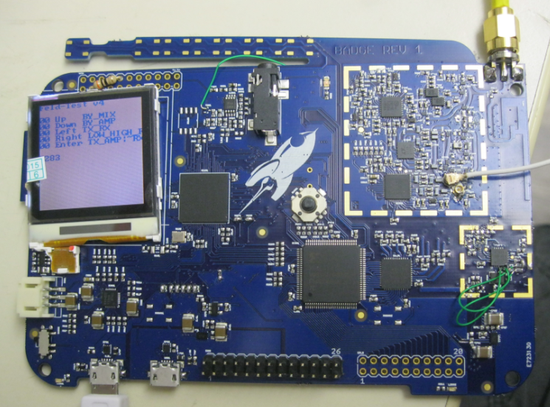

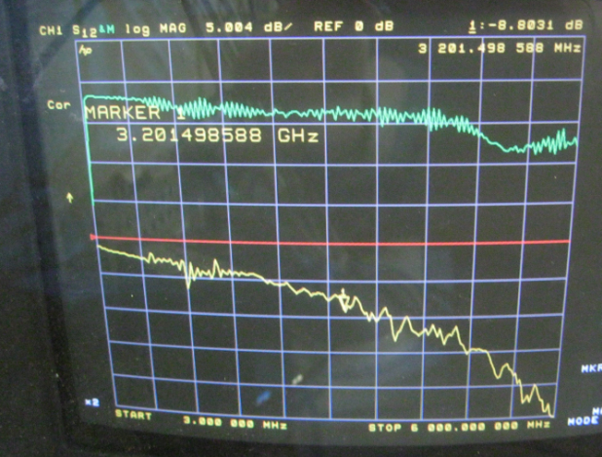
2.2 RX-Path to the WIMAX
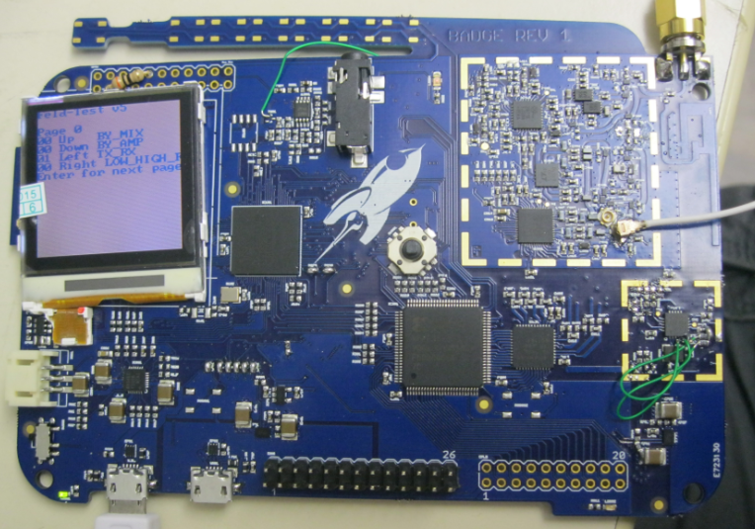

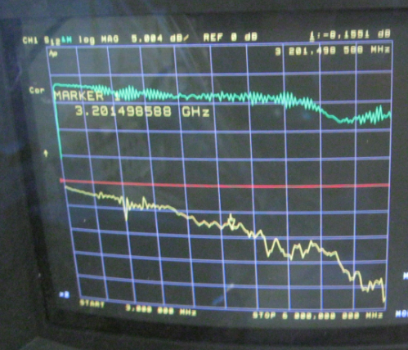
3. Synthesizer + Reference to the Synthesizer

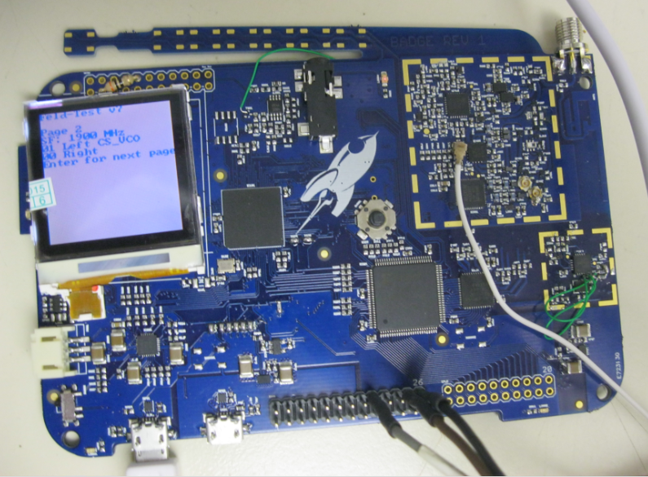

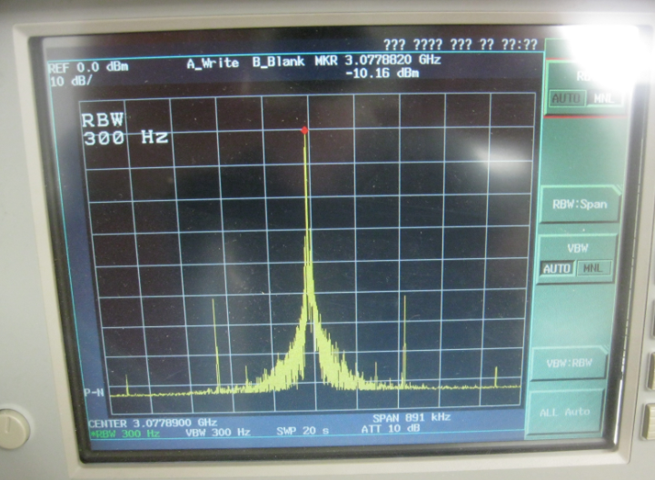
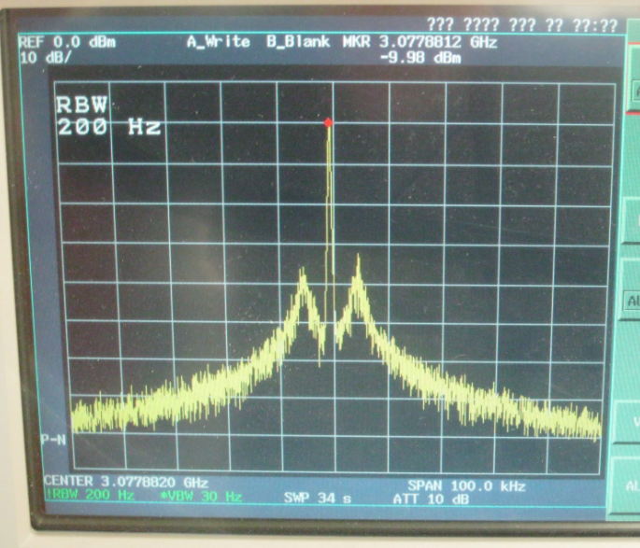

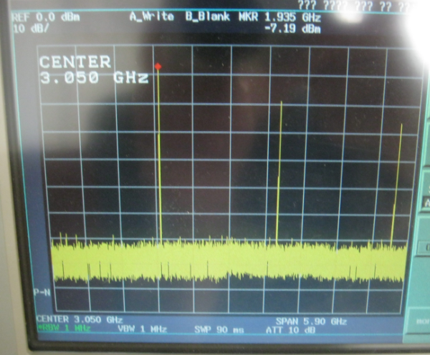
4. Highpass and Lowpass
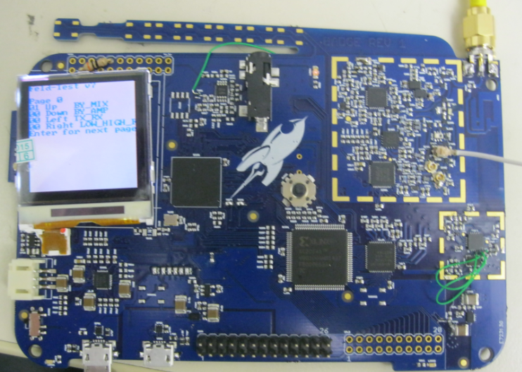

4.1 Lowpass

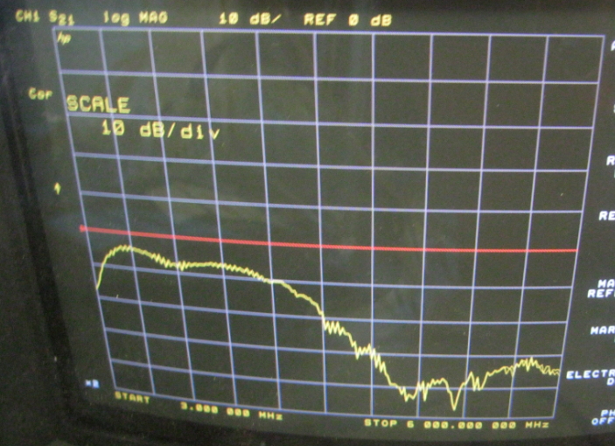

4.2 Highpass
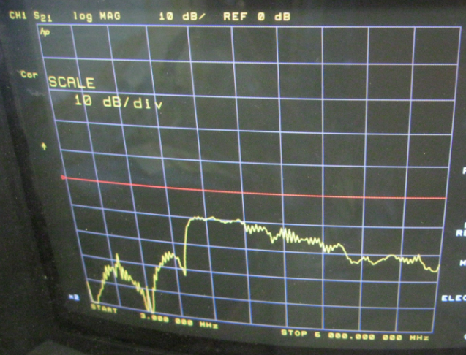

5. Mixer

5.1 Power Signal generator

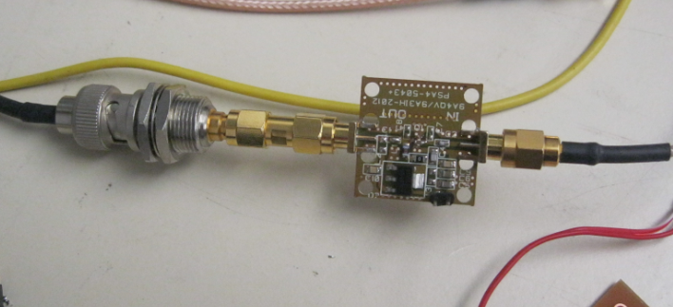
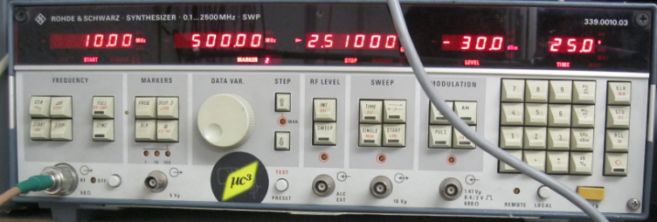

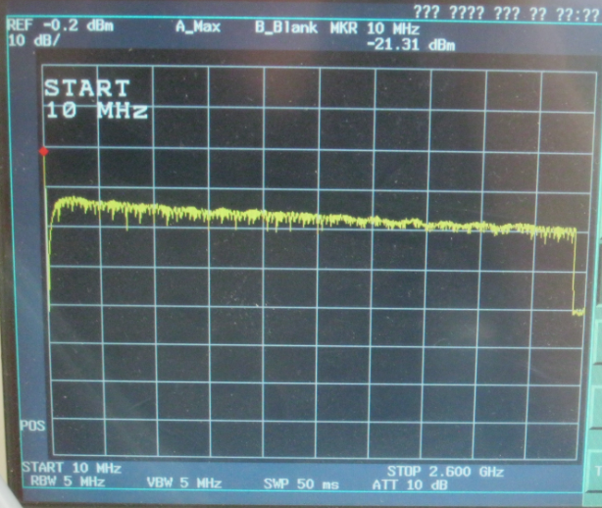

5.2 RX
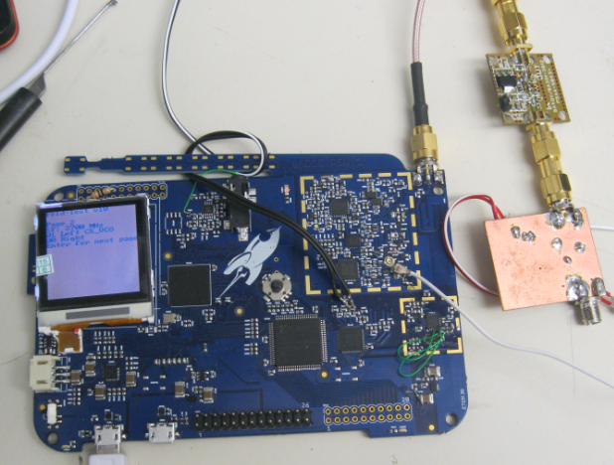

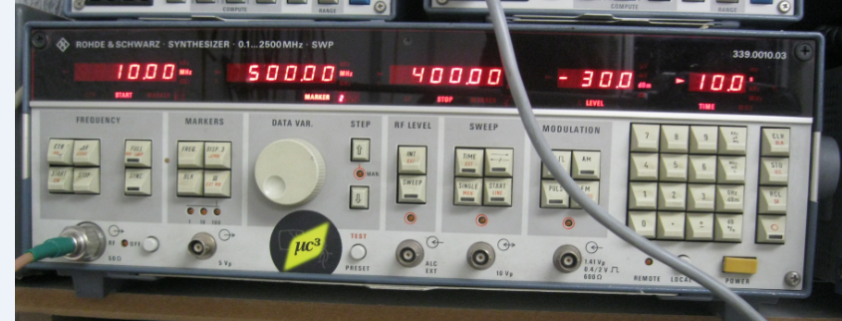

Input [MHz] | Synthesizer Frequency [MHz] | Spectrum analyser [MHz]
10-400 | 2700 | 2300-2700
400-800 | 3100 | 2300-2700
800-1200 | 3500 | 2300-2700
1200-1600 | 3900 | 2300-2700
1600-2000 | 4300 | 2300-2700
2000-2400 | 4700 | 2300-2700
2300-2700 | Bypass mode | 2300-2700

Mixer

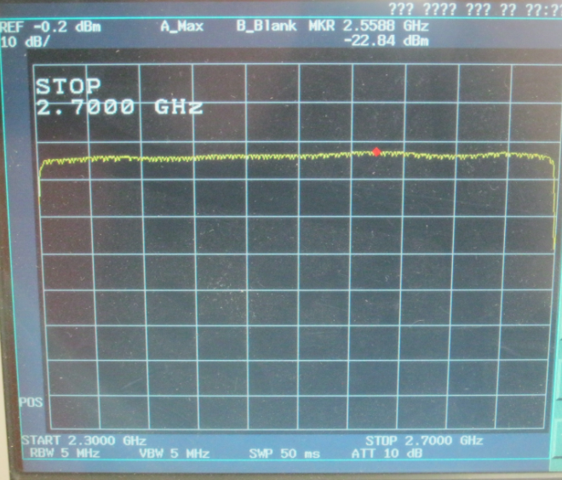
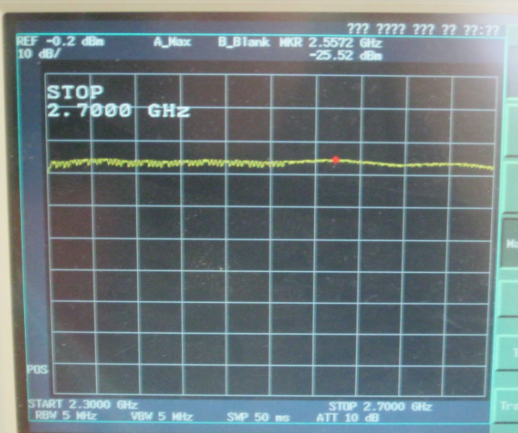
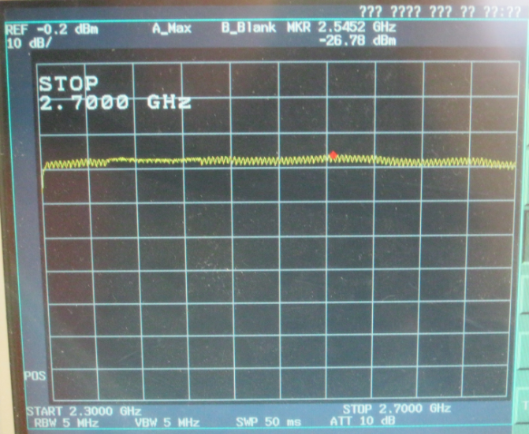
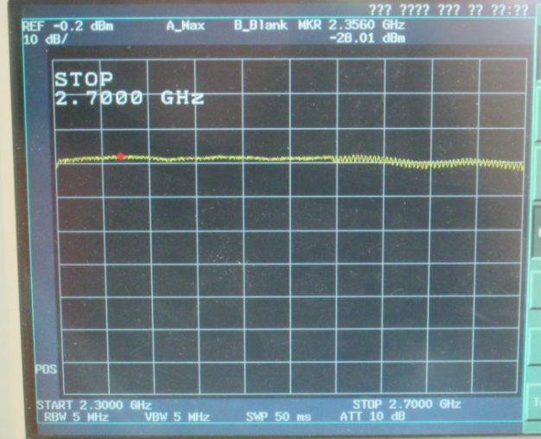
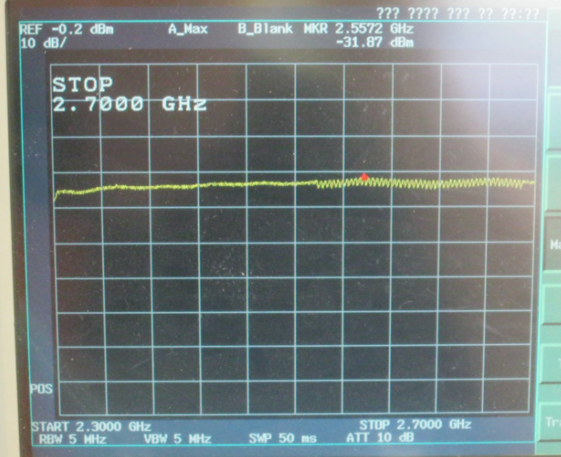

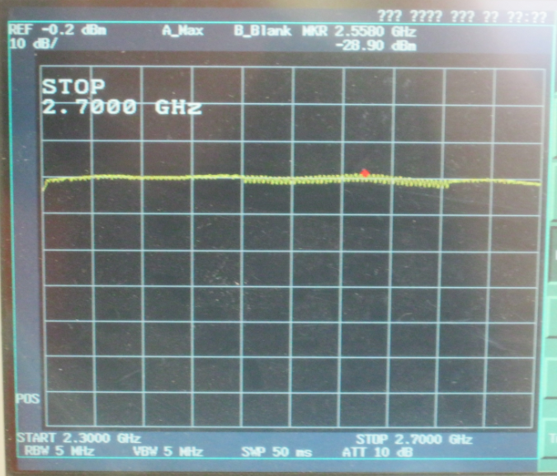

Bypass
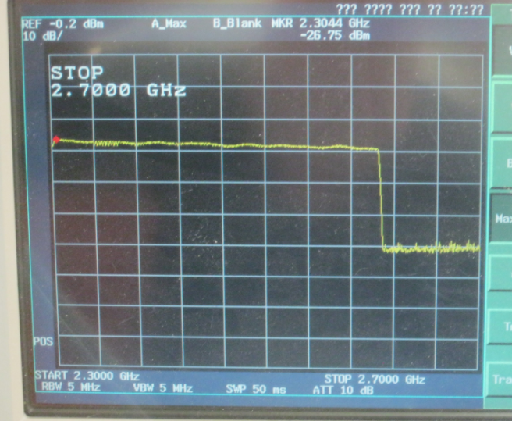
5.2 TX

Input [MHz] | Synthesizer Frequency [MHz] | Spectrum analyser [MHz]
2200-2600 | 2600 | 10-400
2200-2600 | 3000 | 400-800
2200-2600 | 3400 | 800-1200
2200-2600 | 3800 | 1200-1600
2200-2600 | 4200 | 1600-2000
2200-2600 | 4600 | 2000-2400
2200-2600 | Bypass mode | 2200-2600

Mixer
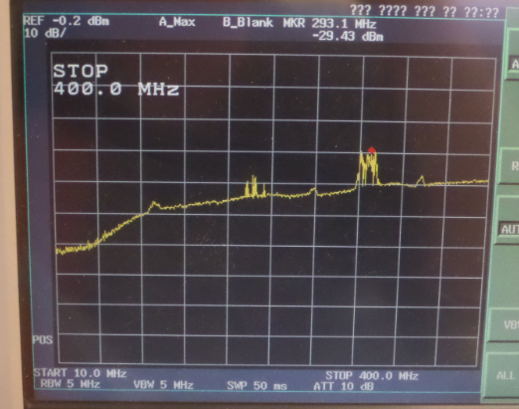
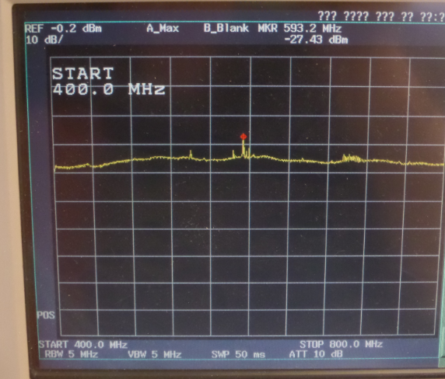

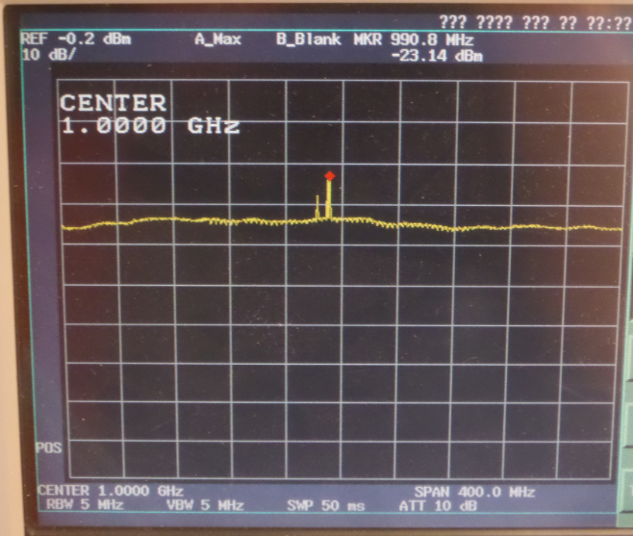
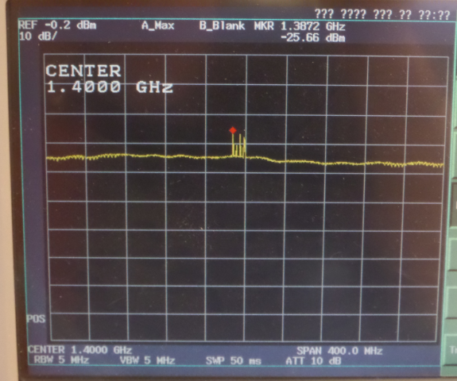
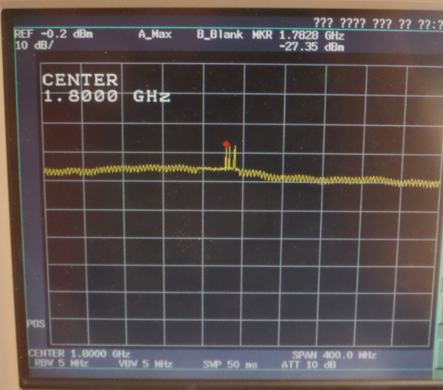
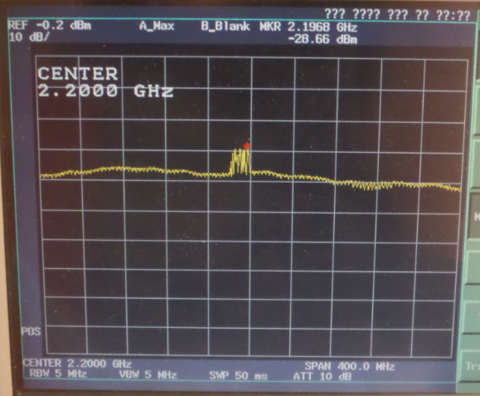

Bypass
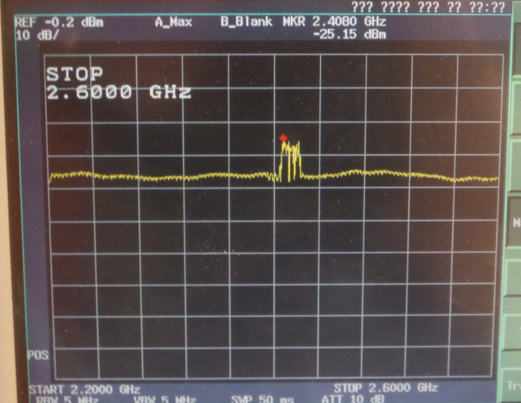

6. TX-Output (unwanted emission)

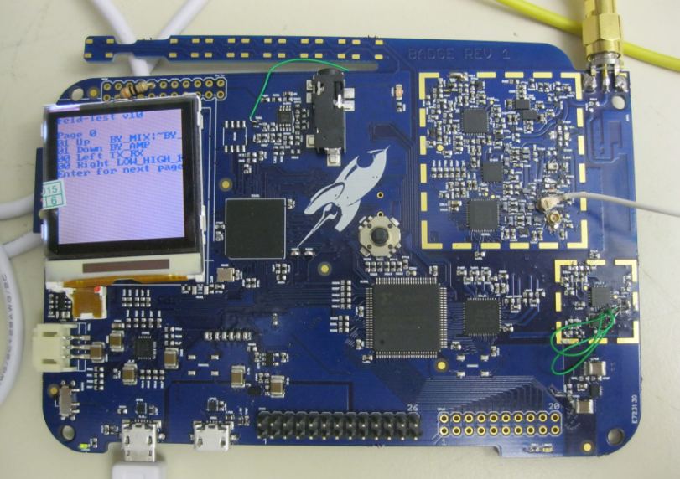

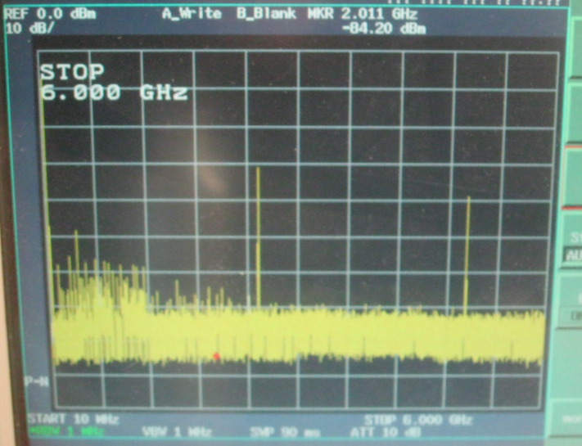

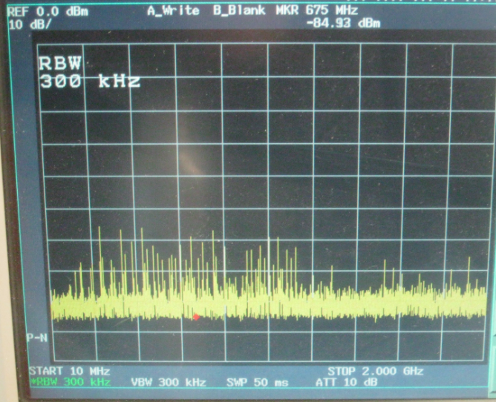

7. Antenna onboard



